 Important Information for All Faculty
Blackboard (Bb) 9.0 Transition Report – April 30, 2009
We’re making the transition from Bb 6.0 to Bb 9.0 in the next few weeks. If you are a current Bb user, you will want to do some very important things to facilitate your successful transition to our new Bb.

- Reserve your spot in a training session. All scheduled training sessions are in the LRC, Room 203.
  - One-day training sessions:
May 11 or May 13 or May 14, 1:00-5:00 PM
Select one day. Please reserve by May 1.
(Summer online instructors get first priority).
  - I will be available for individual and small group trainings from May 1 through May 21. Please contact me to arrange for a special training.
  - Multi-day training sessions:
June, July, and August training sessions are multiple days. Please plan to attend all days of a session. I’ll send out a training agenda soon, so you know what to expect on each day.
June 1-4, 8:00-11:00 AM (Please reserve by May 18.), or
July 20-23, 7:30-10:30 AM (Please reserve by July 6.), or
August 3-6, 8:00 – 11:00 AM (Please reserve by July 20.)
  - I will schedule additional trainings throughout the 2009-2010 year. Watch your email for announcements.

- You will not be able to use the old version of Blackboard after the end of the spring 2009 semester, so you should do the following:
  - Select Bb course shells that you want to copy and use in the new Bb. With our new version of Bb, you will automatically get a new Bb course shell for each class you are teaching each semester. We recommend that you “export” Bb courses that you have developed and used in our current Bb system (Release 6) and “import” that content into the new version of Bb, so you do not have to totally rebuild your courses. (Course content left on our current Bb server will be available for access only until June 30, 2009.)
  - Export selected Bb course shells. Within the course that you want to export, go to Control Panel>Course Options>Export Course
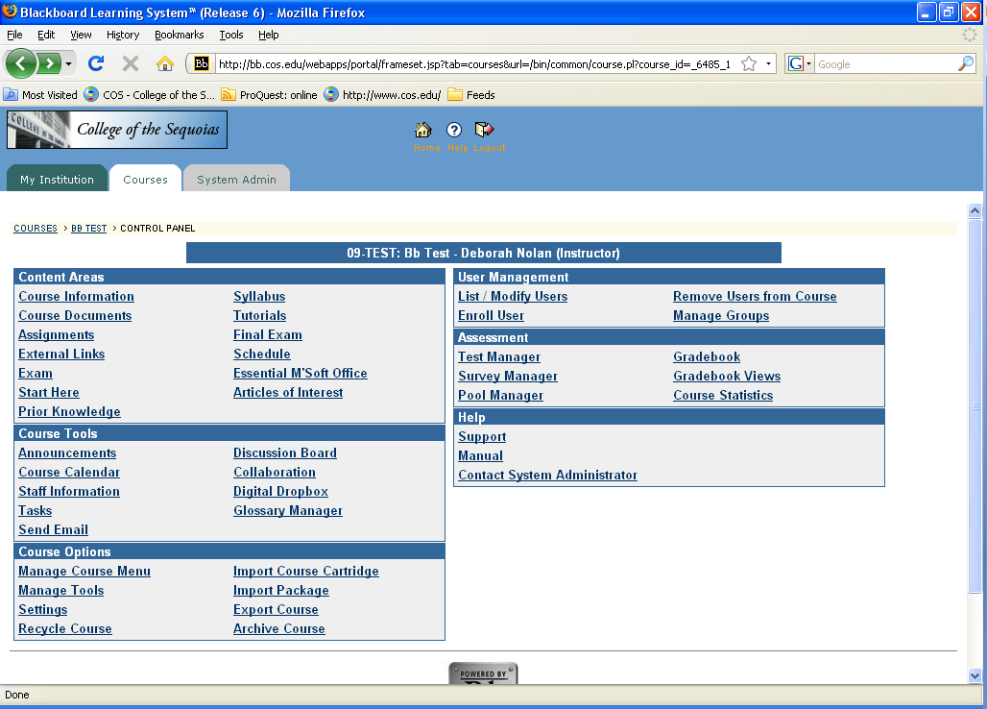

>Select Course Materials
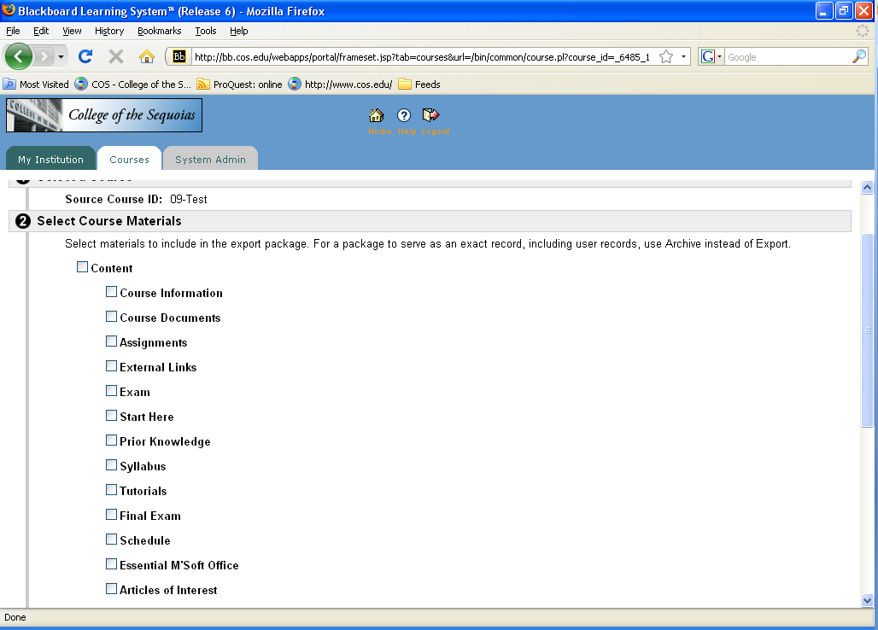

>Submit
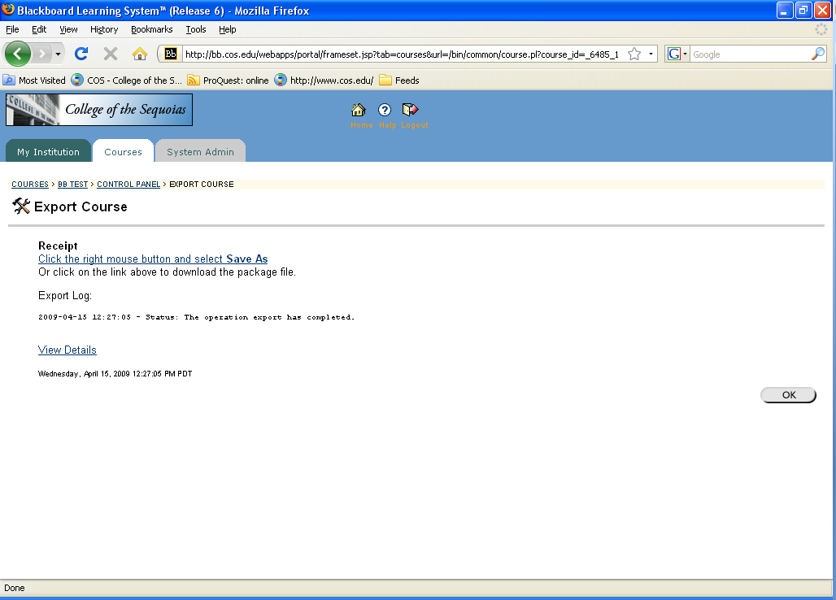

On the words, Click the right mouse button and select Save As, right click your mouse and select “Save Link As.”

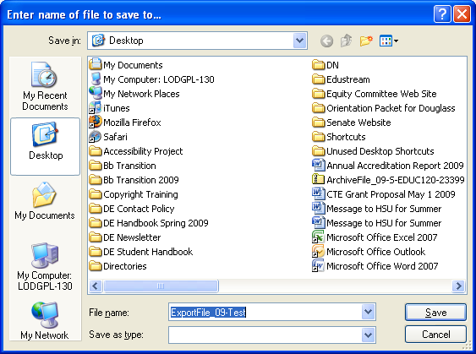

Select a location on your computer (or storage device). For easy retrieval, we recommend that you rename your file to the title of your course. Click Save. Click OK. When you get your new Bb shells before the beginning of the semester, you will be able to import the saved content into the new shell. You will receive directions for importing course content in the near future.
  - If you use publishers’ course content cartridges in your Bb course, please contact your publisher for a new cartridge that is compatible with Bb 9.0. Instructions for uploading publishers’ cartridges are forthcoming.
  - Contact Deborah with questions (deborahn@cos.edu, 737.6132).
  - Watch your email for more news about our transition to Bb 9.0.

